INF20028: Professional Capabilities for a Digital World

**Assignment 1.2:**

**Ethical Dilemmas Analysis**

Name: Nguyen Dinh Nhat Minh

ID: 103802490

Lecturer: Pham Thai Ky Trung

Link to presentation slides: <https://www.canva.com/design/DAGA39DR7K8/YnGncxt7P5j9DDuZLMFObA/view?utm_content=DAGA39DR7K8&utm_campaign=designshare&utm_medium=link&utm_source=editor>

Link to video: <https://youtu.be/y4nSGlIJ37U>

**Presentation Transcript**

**Introduction**

Hello, I’m Nhat Minh and welcome to my presentation on ethical dilemma analysis.

Within this presentation, I will attempt to use the critical analysis framework to justify and analyze one of the most pending issues within today’s world. Ethical Dilemmas.

**Definition of Moral Dilemmas**

As defined by Crowder & Turvey, 2013 an ethical dilemma occurs when available choices in a situation prevent achieving an ethical outcome, necessitating a decision where all options violate ethical principles. To understand we shall move on to one of the most notable examples of this is the classic Trolley problem.

**Example**

**Trolley Problem**

The Trolley Problem, introduced in 1967 by Philia Foot in defense for the Doctrine of Double Effect[1], presents a scenario when a trolley is hurling towards a group of 5 people, should the trolley continue on its current path, it will inevitably strike and kill all five individuals. However, there exists a lever that, if pulled, would divert the trolley onto an alternate track, sparing the five individuals, but resulting in the death of a single person who happens to be on that track.

This moral conundrum forces individuals to grapple with questions of consequentialism, moral responsibility, and the ethical implications of acting versus inaction in the face of impending harm.

More than 90% of people that was presented with this problem in the 2011 test by the Michigan State University would choose to kill the one person in favor of five as can be seen in the table here:

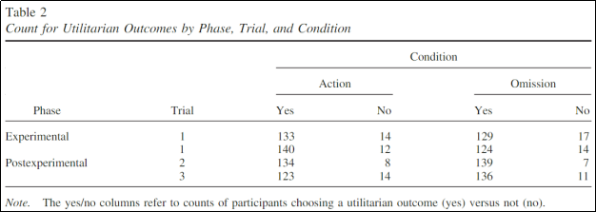

*The action condition is to pull the lever, letting 1 person die.

*The omission condition is a scenario where the number of people in the trolley problem are switched, and by not pulling the lever, 1 person would die.

So within the confines of the trolley problem it is safe to assume that, most people would approach it with the utilitarianism mindset that prioritizing minimizing the overall number of deaths, will lead to a greater overall consequence.

**Autonomous Vehicle**

Now let’s move on to the modern era where technologies and automation are on the rise, the trolley problem has evolved into a question of ethical decision-making in automated systems and artificial intelligence. This leads to situations where self-driving cars must navigate complex scenarios where harm to humans is unavoidable.

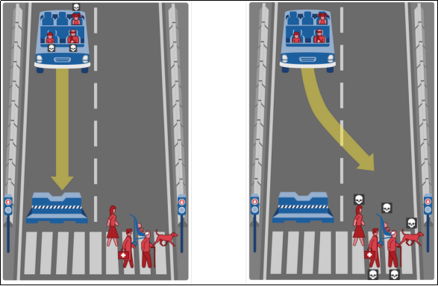

An example of this is a scenario first brought up by Bonnefon, et al in 2016 where an autonomous car faces a situation where it must choose between two unavoidable accidents, each resulting in harm to different parties (e.g., passengers, pedestrians, or other drivers). The car's programming must decide which course of action to take, raising questions about how to prioritize the safety of different individuals and how to assign value to human life in such situations.

**Critical Analysis**

**Situation, stakeholder**

We will take the autonomous car as the medium to apply our critical analysis on and so far, we have defined the situation – autonomous vehicle problem, stakeholders – people in and outside the car, and the ethical dilemma action – to drive into the wall or steer the wheel and crash into the pedestrian.

**Legal consideration**

To further explore this analysis, it's crucial to consider the legal ramifications of such scenarios and determine where liability resides. Takeyoshi Imai raised this question in 2019, pondering whether liability falls on the driver, manufacturers, or even the AI system within the vehicle and stated that the laws provided have yet to resolve issues above. Jessica suggested in 2016, our current legal framework does not account for autonomous vehicles and Chen, et al. in 2017, reasoned that there are still a lot of improvements that must be made within the current laws we have to improve autonomous vehicle’s independence.

So it is safe to assume that the question of whether to judge or base liability of autonomous vehicles on any stakeholders is a question that has yet to have an answer, hence, we need to give it more time for the law to cover it and provide a legal answer for this argument.

**Guidelines**

Since a car, or a non-thinking machine, is the main protagonist in our auto automobile problem, it would be challenging to put oneself in the car's shoes and determine what would be "moral" in the car's eyes because we are unable to evaluate the formal and informal moral rules from the viewpoint of a car.

However, This situation raises an intriguing question about integrating moral principles and policies into the algorithms of self-driving cars, as they lack the capability to determine the most ethical course of action on their own.

Policymakers, ethicists, and car manufacturers can play a crucial role in teaching these systems to make morally sound decisions. Bonnefon (2016) supports this notion, her team's research suggests that the majority of people would prefer AVs to minimize the death toll even if it means sacrificing the lives of its passengers. These points determined that the car should be taught to act on the utilitarian guidelines.

However, JafariNaimi (2017) argues that Bonnefon and her colleagues' argument is overly broad. She proposes that instead of solely relying on utilitarian principles, we should consider the entirety of reality and other factors that make up the situation to refine how these ethical dilemmas are addressed and how future autonomous cars should be better prepared for hard decisions.

Aligning this with the guidelines of the framework, we can see that this approach advocates for a more nuanced understanding rather than rushing headlong into a purely utilitarian approach.

**Ethical principles**

In my view, it's essential to prevent disasters before they occur, and I support the idea of altruism where the car and its passengers are willing to endure some potential harm for the greater good. This concept is backed by research conducted by Toghi, Behrad, et al. in 2022, which suggests that autonomous cars with altruistic tendencies could benefit both humans and other autonomous vehicles.

I believe that the responsibility lies with policymakers and car manufacturers to take action, although users have the right to voice their opinions on the car's design. I draw inspiration from the findings of Chen, et al. in 2017 to support this notion.

The involvement of policymakers and manufacturers is crucial because legislation is needed to mandate the inclusion of advanced emergency brake features (that activate upon sensing imminent, unavoidable danger) in autonomous cars. This proactive approach could save lives, even if it leads to injuries among occupants. This inspiration is taken from a recently proposed technology by Alsuwian, Turki, et al. in 2022 regarding the braking system.

**References**

Alsuwian, T., Saeed, R. B., & Amin, A. A. (2022). Autonomous Vehicle with Emergency Braking Algorithm Based on Multi-Sensor Fusion and Super Twisting Speed Controller. *Applied Sciences*, *12*(17), 8458. <https://doi.org/10.3390/app12178458>

Bonnefon, J.-F. ., Shariff, A., & Rahwan, I. (2016). The social dilemma of autonomous vehicles. *Science*, *352*(6293), 1573–1576. <https://doi.org/10.1126/science.aaf2654>

Brodsky, J. S. (2016). Autonomous Vehicle Regulation: How an Uncertain Legal Landscape May Hit The Brakes on Self-Driving Cars. *Berkeley Technology Law Journal*. <https://doi.org/10.15779/Z38JC5S>

Crowder, S., & Turvey, B. E. (2013). Ethics in the Criminal Justice Professions. *Ethical Justice*, *1*, 1–19. <https://doi.org/10.1016/b978-0-12-404597-2.00001-2>

Foot, P. (1967). The Problem of Abortion and the Doctrine of Double Effect. *Oxford Review*. 5, 5-15.

Imai, T. (2019). Legal regulation of autonomous driving technology: Current conditions and issues in Japan. *IATSS Research*, *43*(4), 263–267. <https://doi.org/10.1016/j.iatssr.2019.11.009>

JafariNaimi, N. (2017). Our Bodies in the Trolley’s Path, or Why Self-driving Cars Must *Not* Be Programmed to Kill. *Science, Technology, & Human Values*, *43*(2), 302–323. <https://doi.org/10.1177/0162243917718942>

Lv, C., Cao, D., Zhao, Y., Auger, D. J., Sullman, M., Wang, H., Dutka, L. M., Skrypchuk, L., & Mouzakitis, A. (2017). Analysis of autopilot disengagements occurring during autonomous vehicle testing. *IEEE/CAA Journal of Automatica Sinica*, *5*(1), 58–68. <https://doi.org/10.1109/jas.2017.7510745>

Navarrete, C. D., McDonald, M. M., Mott, M. L., & Asher, B. (2012). Virtual morality: Emotion and action in a simulated three-dimensional “trolley problem”.. *Emotion*, *12*(2), 364–370. <https://doi.org/10.1037/a0025561>

Toghi, B., Valiente, R., Sadigh, D., Pedarsani, R., & Fallah, Y. P. (2022). Social Coordination and Altruism in Autonomous Driving. *IEEE Transactions on Intelligent Transportation Systems*, *23*(12), 24791–24804. <https://doi.org/10.1109/TITS.2022.3207872>

**External Resources**

[1] McIntyre, A. (2018, December 24). *Doctrine of Double Effect (Stanford Encyclopedia of Philosophy)*. Stanford.edu. <https://plato.stanford.edu/entries/double-effect/>